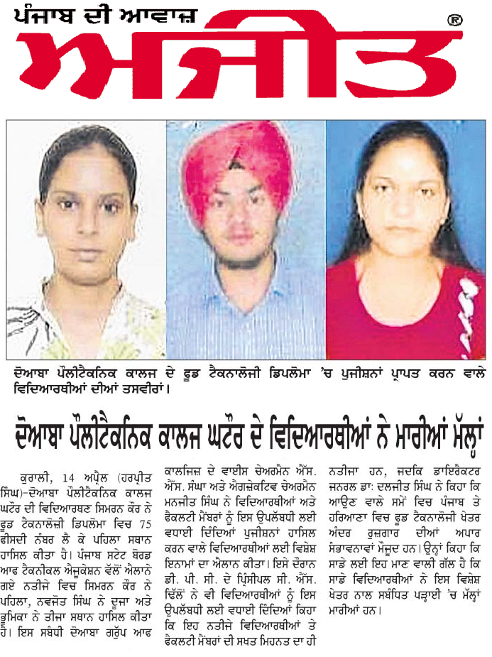
http://epaper.ajitjalandhar.com/edition/20170415/16/6/12.cms

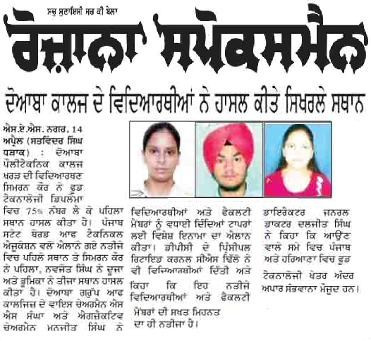

http://www.newsepapers.com/indian/punjabi/rozana-spokesman-epaper/

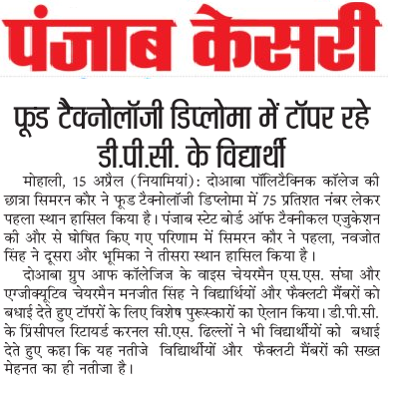

http://epaper.punjabkesari.in/1173182/punjab-kesari-chandigarh-kesari/Chandigarh-kesari#page/4/3

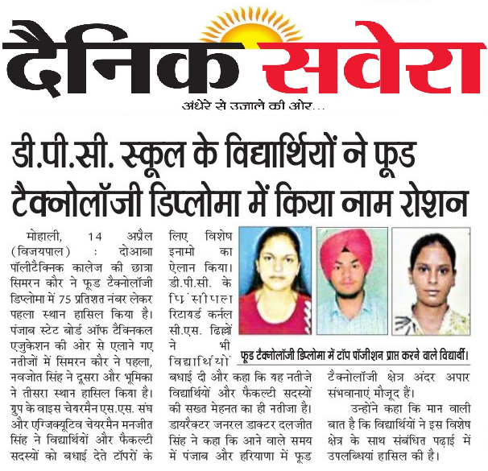

http://dainiksaveratimes.epapr.in/c/18396755

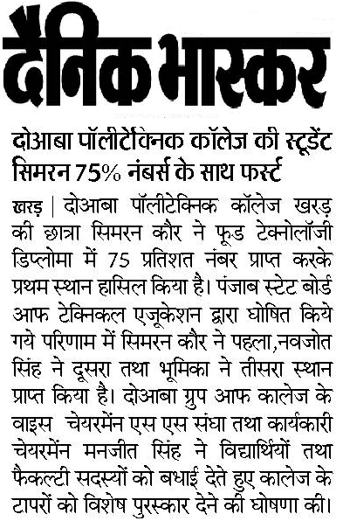

http://epaper.bhaskar.com/detail/878914/41512213453/cph/map/tabs-1/04-15-2017/319/3/image/

